**VISVESVARAYA TECHNOLOGICAL UNIVERSITY, BELGAUM 590014**



Programming in Python

**“AUTOMATED BILLING SYSTEM”**

By

SUMUKH SUBRAMANYA H K (1BM17CS106)

TANMAY GOEL (1BM17CS112)

TANUSH N (1BM17CS114)

Under the Guidance of

**Prof. SELVA KUMAR S**

Assistant Professor, Department of CSE

BMS College of Engineering

Programming in Python Self-study Project carried out at



Department of Computer Science and Engineering

BMS College of Engineering

(Autonomous college under VTU)

P.O. Box No.: 1908, Bull Temple Road, Bangalore-560 019

Aug-Dec 2018

**BMS College of EngineerinG**

**DEPARTMENT OF COMPUTER SCIENCE AND ENGINEERING**



***CERTIFICATE***

This is to certify that the Programming in Python titled “**AUTOMATED BILLINGSYSTEM**” has been carried out by **SUMUKH SUBRAMANYA H K** (1BM17CS106), **TANMAY GOEL** (1BM17CS112) **and TANUSH N** (1BM17CS114) during the academic year Aug – Dec 2019.

Signature of the guide

**Prof. SELVA KUMAR S**

Assistant Professor

Department of Computer Science and Engineering

BMS College of Engineering, Bangalore

**BMS College of EngineerinG**

**DEPARTMENT OF COMPUTER SCIENCE AND ENGINEERING**



***DECALARATION***

We, **SUMUKH SUBRAMANYA H K** (1BM17CS106), **TANMAY GOEL** (1BM17CS112) and **TANUSH N** (1BM17CS114), students of 5th Semester, B.E, Department of Computer Science and Engineering, BMS College of Engineering, Bangalore, hereby declare that, this Programmingin Pythonwork entitled "**AUTOMATED BILLING SYSTEM**" has been carried out by us under the guidance of Prof. Selva kumar S, Assistant Professor, Department of CSE, BMS College of Engineering, Bangalore during the academic semester Aug-Dec 2019

We also declare that to the best of our knowledge and belief, the development reported here is not from part of any other report by any other students.

Signature

**SUMUKH SUBRAMANYA H K (1BM17CS106)**

**TANMAY GOEL (1BM17CS112)**

**TANUSH N (1BM17CS114)**

1. INTRODUCTION

Who likes to stand in long queues in super markets! People waste their time standing in long queues just to get their bill. This is not acceptable anymore!

Automated Billing System is a project where the billing process is automated and the user need not stand in long queues waiting for their bill after buying the products which is the case in manual billing.

In our proposed system , there would be No long queues! No wait! Automatic Online Billing! Life suddenly feels simple.

2. DESCRIPTION

We would be combining IOT (Internet Of Things) along with Python in this project.

The front-end part for the admin is designed using Tkinter which is a python GUI (Graphical User Interface).

The backend part of the project is done using sqlite3 which is the database part to store details of the products and customers.

The products will be scanned using RFID technology, which will be the IOT part, and once scanned, the details will be sent to the database which is being maintained using python. The details will be stored in tables using which the admin of the shop can access the required details also. He will be given provisions to add, delete, view, or update items to his shops, add, update, view, or delete new customers.

Once the product is scanned it will be automatically stored in a table in the database along with the date and time of scanning.

3.REQUIREMENTS:

System Requirements:

1. Python IDLE

Concepts used:

1. Tkinter-Front End
2. Sqlite3-Back End

3. User-Interface screen shots

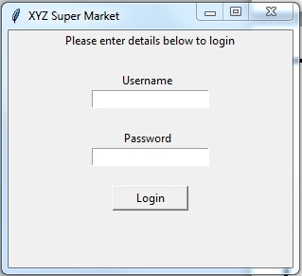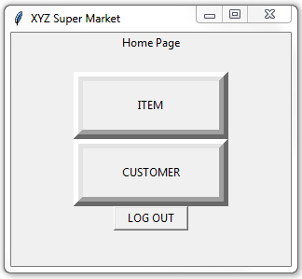

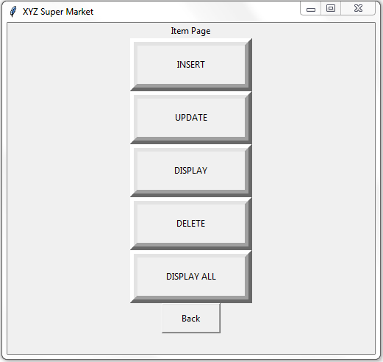 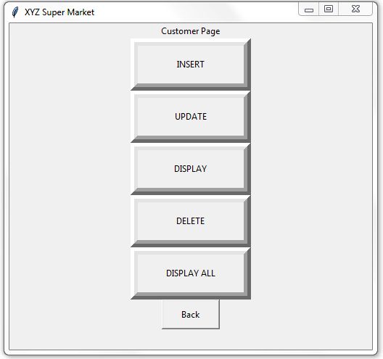

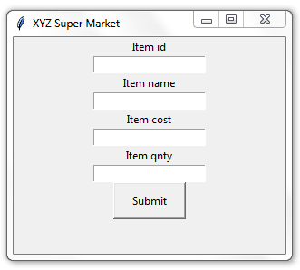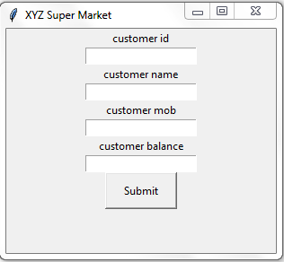

4. Database Table screen shots

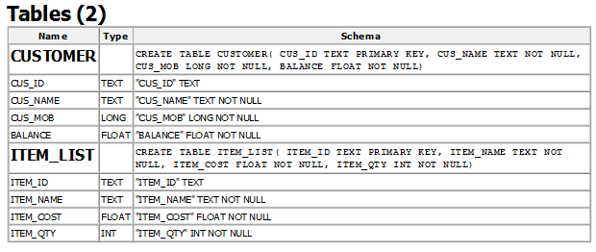

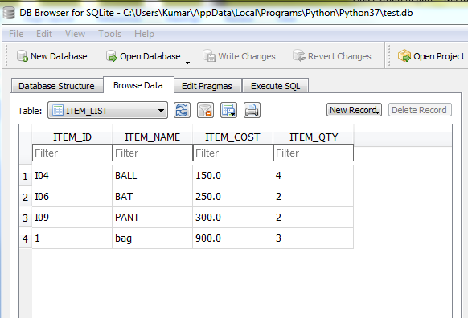

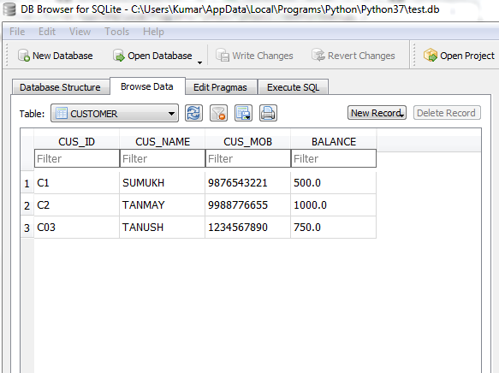

**CONCLUSION:**

The automated billing system provides a user friendly access. Details can be easily maintained and accessing from database is easier. This tremendously reduces the physical or the manual work of storing details and checking them. It can be used by any super markets. By using this it makes their work a lot easier.